

2 Minute Form
Trip Name: Browns Bay to Dacre Cottage
Check-in Name and Phone:
Date: Branch:
Leaders
Cell Phone Number
VHF Call Sign &/or Vessel Name
Vehicle make, model, registration, colour
General Plan
Note: If plan changes, you must notify your Check-in person.
Latest Time Off the Water |  |  |  |  | TMP/ AMP used²⁰
Tide/ Forecast Lake Level | Low |  |  | High | Other
Communications Carried²¹
Communications | We will be communicating as a group on VHF Channel _____
Equipment Carried
Trip Report
(Use other side if more space required)

Activity |  |  | Strong beginners paddle |  |  |  | Centre | North Shore |  |  | Location |  |  |  |  |  |  | Minimum Difficulty¹ |  |  |  |  | Strong beginner
Activity Description |  |  | Browns Bay to Dacre Cottage |  |  |  |  |  |  |  |  | Leader qualification req.² |  |  |  | Trip Leader
Get in Location |  |  | Northern Browns Bay beach |  |  |  |  |  |  |  |  | Chart/ Map no.⁴ |  |  |  | 5321 |  | Distance |  |  |  |  | 15-18 km
Get out Location |  |  | ditto |  |  |  |  |  |  |  |  | Coastguard Channel |  |  |  | 82 & 16 |  | Nowcasting |  |  |  |  | 21
Emergency get out ⁵ |  |  | North Shore coastline. |  |  |  |  |  |  |  |  | Emergency / Coastguard Station |  |  |  | Auckland |  | Phone |  |  |  |  | *500  09 303 4303
 |  |  |  |  |  |  |  |  |  |  |  | Drinking Water⁶ |  |  | East Coast Beaches (not Dacre Cottage) |  | Toilets⁷ |  |  |  | All Bays including Dacre Cottage
Emergency Response |  |  | Refer Emergency Response Booklet |  |  |  |  |  |  |  |  |  |  |  |  |  | Parking⁸ |  |  |  | Northern Browns Bay beach
Specific Equipment Required⁹ |  |  | High vis clothing. |  |  |  |  |  |  |  |  | Working Communications equipment in this area¹⁰ |  |  | Cell phone  Sat phone |  |  |  |  |  |  |  |  | PLB  VHF
Other resources  and notes¹¹ |  |  |  |  |  |  |  |  |  |  |  | Weather Parameters¹² |  |  | Beginner 15 kn in exposed areas
Previous incidents¹³
Safety Management¹⁴
Hazard |  | Signifi-cant? |  | Management Strategy¹⁵ |  |  |  |  |  | Hazard |  |  | Signifi-cant? | Management Strategy¹⁵
Cold Water |  | Yes |  | Carry spare dry clothes and shelter |  |  |  |  |  | Deep Water |  |  | Yes | Correctly fit PFDs
Medical Conditions |  | Yes |  | - Leader has first aid qualification  - Ask customers about medical conditions |  |  |  |  |  | Bad Weather |  |  | Yes | Understand weather forecasts.  Have back up plans or pull out if necessary
Capsizing |  | Yes |  | - Correctly fit Pfds  - Skills at performing rescues. |  |  |  |  |  | Heat / Sun |  |  | Yes | - Protective Clothing (worn)  - Sun Screen  - Plenty of drinks  - Sunglasses
Panic |  | Yes |  | Ensure conditions match level  of skills |  |  |  |  |  | Obstacles |  |  | Ye s | Awareness of reefs, navigational hazards, nets
Current |  |  |  | - Travel with tide |  |  |  |  |  | Other Vessels |  |  | Yes | - Understand the “rules of the sea”  - “Be seen” – Have two of the following; flag, brightly coloured kayak, brightly coloured Pfd or hat. At night: an all round white light & a powerful torch.
Other Hazards |  |  |  |  |  |  |  |  |  | Other Hazards
Written up by: | Joya Todd |  |  |  | Approved By: | Rob Howarth |  |  | Signed: |  |  |  | Date: | 30 April 2014 |  |  |  |  | Review in: |  |  | 12 months from date of approval
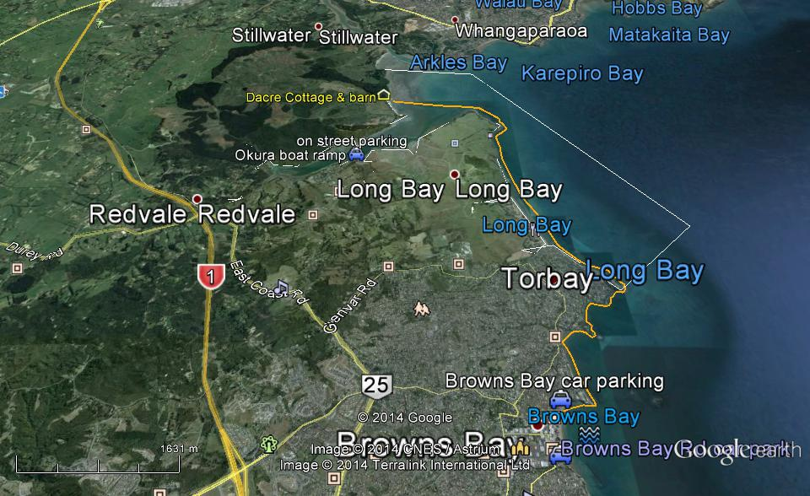
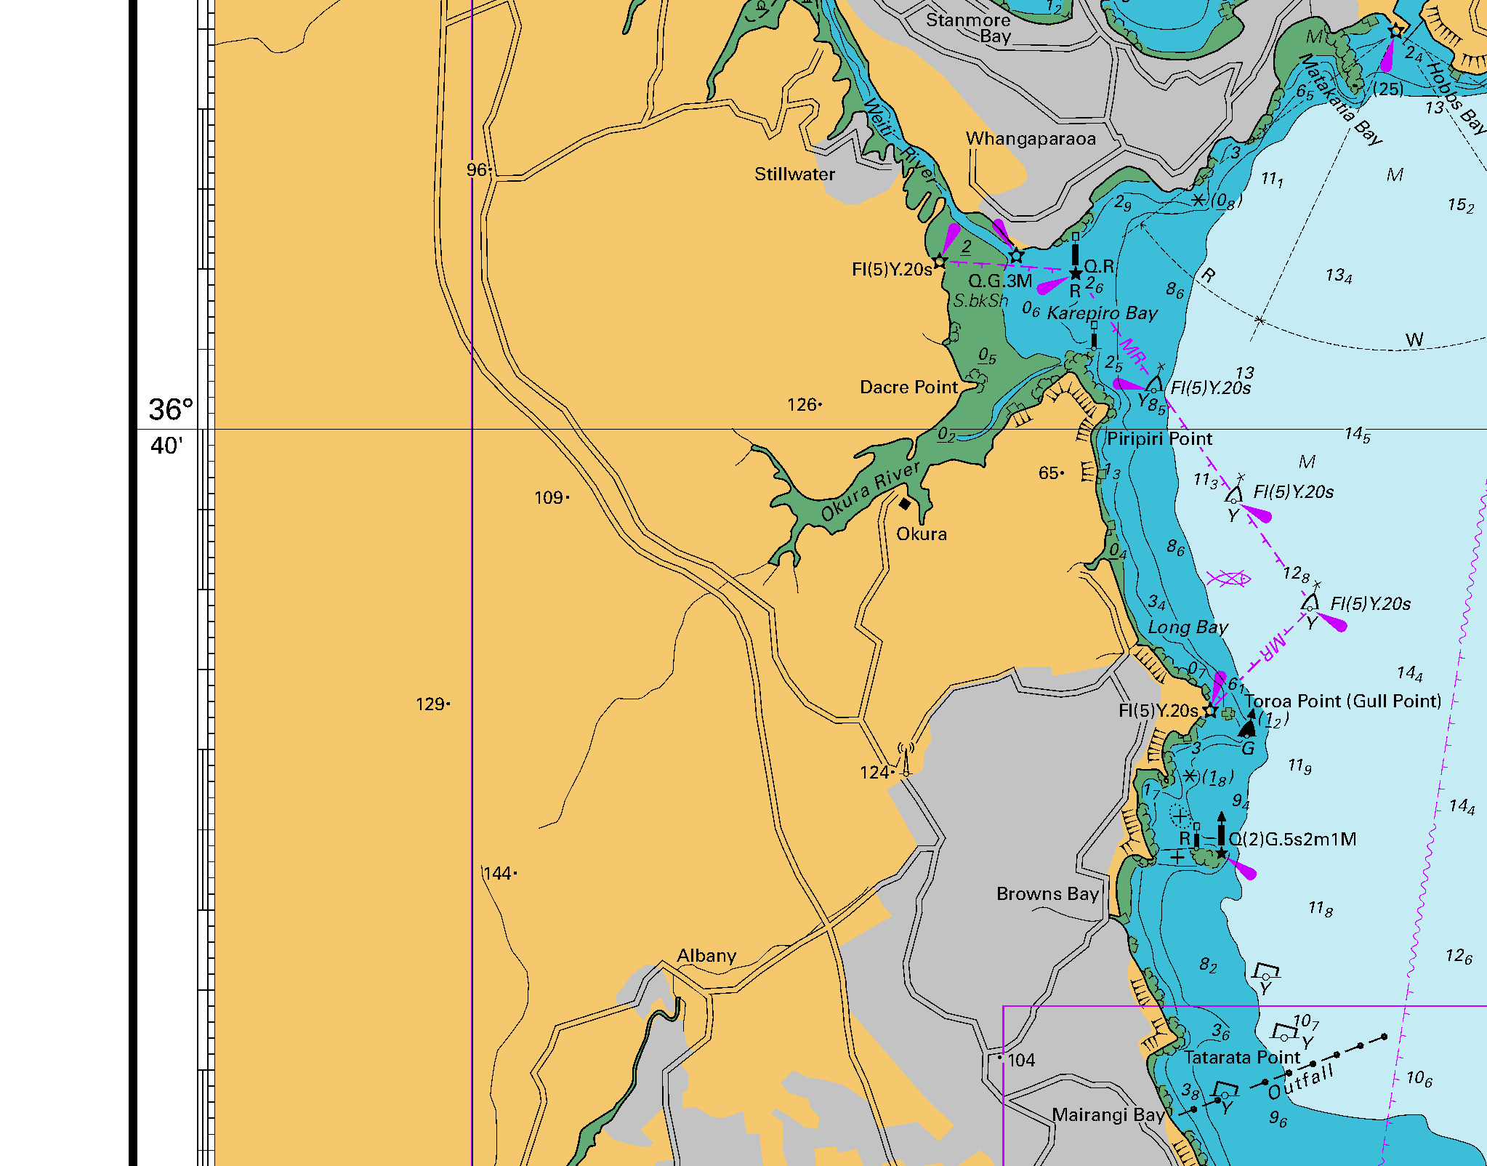
Additional Information Sheet (Optional)
Introduction (A general introduction)
Description (A description of the tour – as if you were selling the idea to someone)
Local Attractions |  | Transport/ Local Operators
 | Contact details |  | Contact details
Local Eateries
 | Contact details
Accommodation/ Campsite Locations |  |  | Facilities
Name |  |  | Cabins |  | Fuel
Phone |  |  | Showers |  | Power
E-mail |  |  | Toilets |  | Water Access
Website |  |  | Laundry |  | Pool
Physical Address |  |  | Water |  | Fires Allowed
Other |  |  | Supplies
Other information

